Victorian Autism Plan update
February 2018

Work is underway on the development of the Victorian Autism Plan.

What is the Victorian Autism Plan?
The Victorian Autism Plan is being developed in response to a Parliamentary Inquiry < https://goo.gl/8dJya8 > into services for people with autism. The Inquiry found that there is a need for change, with major problems with existing services. It found that Victorians with autism and their families lack access to the supports they need to lead normal lives.
The Plan will include short, medium and long-term actions over five years.

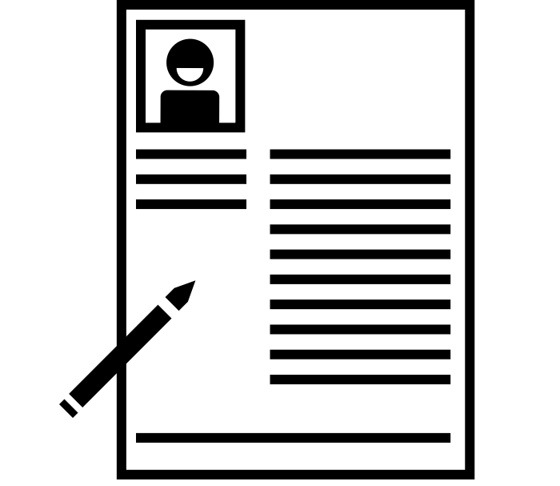What is happening with the Plan?
The Victorian Government is in the process of drafting the Plan, using the expertise of people with autism, their families and supporters, autism-specific organisations and other relevant individuals and organisations.
The Victorian Autism Plan Advisory Group has been established to represent a broad range of people with autism, their families and supporters and includes representatives from:
- Amaze
- Aspergers Victoria
- Association for Children with a Disability
- Autism Family Support Association
- I CAN Network
- Victorian Advocacy League for Individuals with Disability (VALiD)
- Victorian Disability Advisory Council
- National Disability Services
  - Yellow Ladybugs.

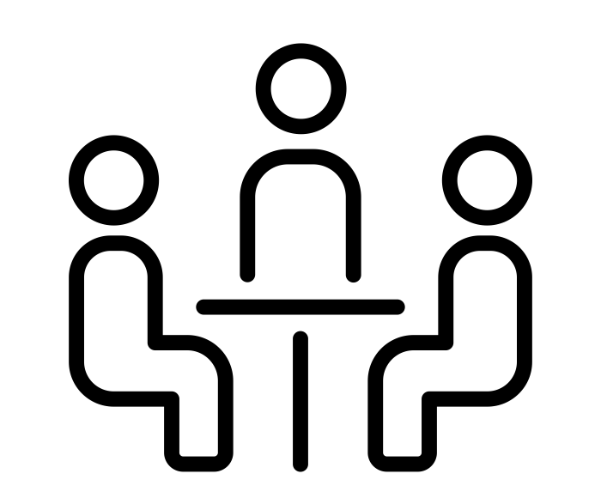How can I have my say on the Plan?
The Victorian Government is arranging a series of consultation workshops in February and March 2018.
This will enable organisations and individuals – including people with autism and their families – to have their say on the Plan.
Each workshop will cover a specific topic, including diagnosis, integrated and coordinated services, school education, health and mental health, services for adults with autism and rural and regional issues.
Shorter meetings with specific organisations will also help to inform the development of the Plan.

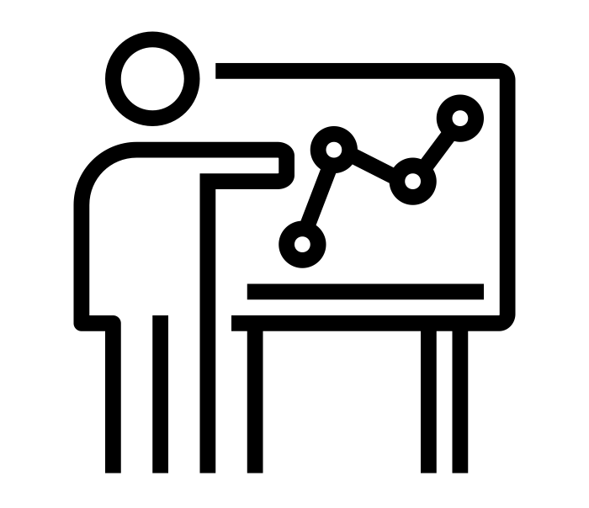What will happen in the workshops?
At these workshops, attendees will look at a number of actions that respond to Inquiry recommendations and, led by an experienced facilitator, discuss and give feedback on these actions.
Arrangements for the workshops will consider the needs of people with autism and their families, to ensure that they feel comfortable and able to participate. If you would like to attend a workshop, email the Victorian Autism Plan project team <victorianautismplan@dhhs.vic.gov.au>

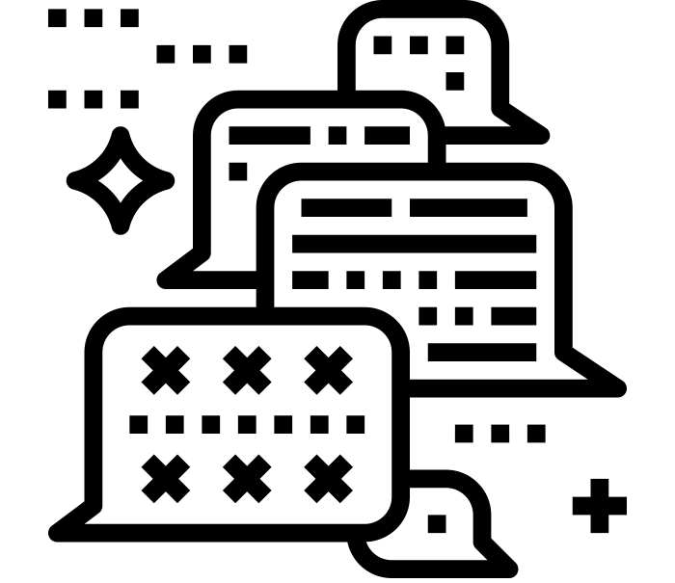What if I can’t get to a workshop, or don’t feel comfortable attending?
If people with autism and their families can’t attend a consultation workshop or don’t feel comfortable attending, they can still have their say.
An online survey will be available via organisations on the Advisory Group so that people in the autism community can provide their comments. This survey will enable people to have their say on topics covered in all workshops, so will be distributed around the time of the final workshop.
You can also email Victorian Autism Plan project team <victorianautismplan@dhhs.vic.gov.au> to ask that it be sent to you when it is available.

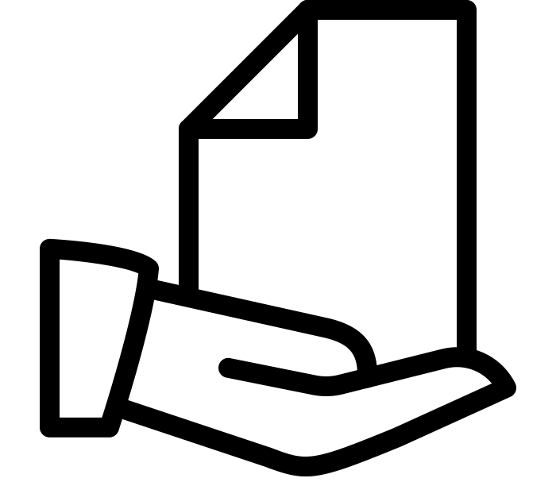What happens after the workshops?
Taking on board the feedback from the workshops, targeted meetings and online surveys, the Victorian Government will draft the Victorian Autism Plan and will keep stakeholders updated on its progress.

When will the Plan be released?
The Plan is expected to be released in the second half of 2018.

How can I find out more?
If you have any questions about the Plan, please email the Victorian Autism Plan project team <victorianautismplan@dhhs.vic.gov.au>

To receive this publication in an accessible format phone 9096 0344, using the National Relay Service 13 36 77 if required, or email the Victorian Autism Plan project team <victorianautismplan@dhhs.vic.gov.au>
Authorised and published by the Victorian Government, 1 Treasury Place, Melbourne.
© State of Victoria, Department of Health and Human Services February 2018.

